Advanced Training Screenshots

USECASE 1 - Screenshots of the conversation where entity amendment is initiated.

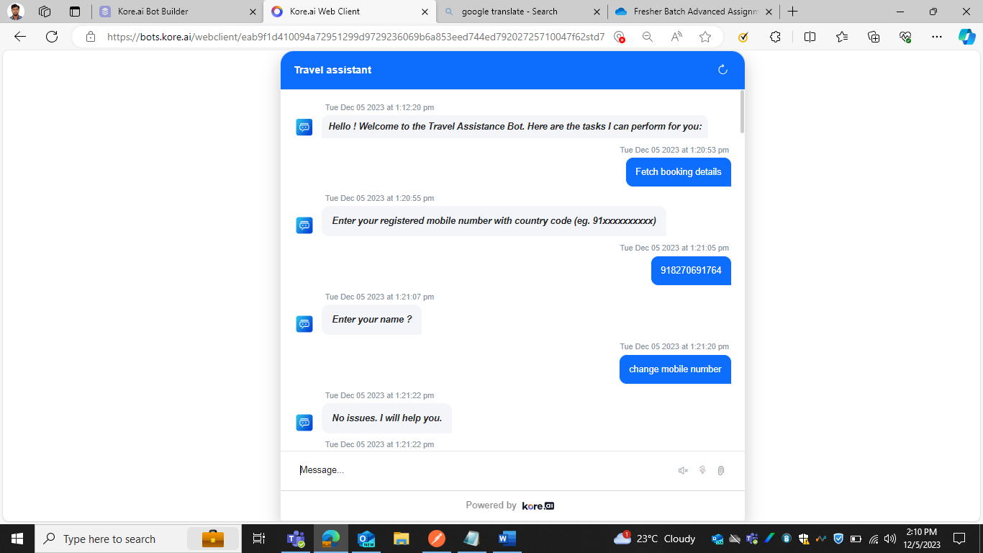

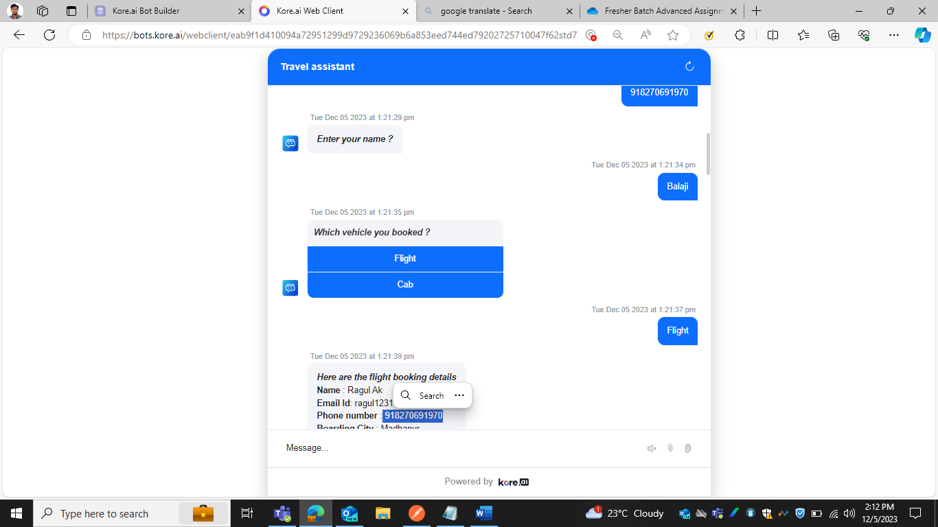

USECASE 2 - Screenshots of the Custom dashboard widgets of Bot.

1. Number of dialog tasks and faqs handled datewise

b)Specific language bot

USECASE 3 - Screenshots of the conversation you have with the bot in these multiple languages enabled.

1. Tamil Faq qualification

1. Tamil conversation with bot to Book Cab

USECASE 4 - API response screenshot (retrieve the Bots Change Logs)

USECASE 5 – Screenshot of feedback report from the Feedback Dashboard in the bot Analytics.

1. CSAT  
   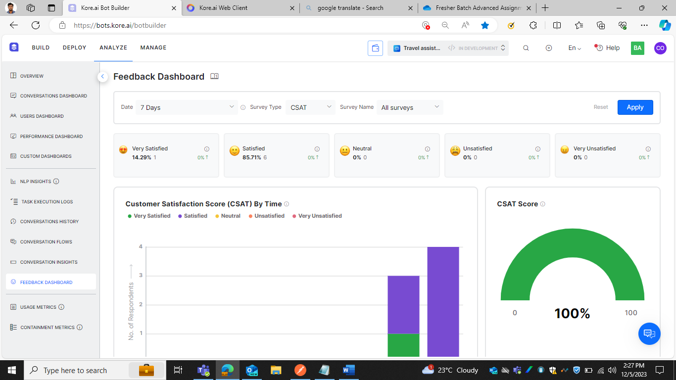

b)NPS

C) Like and Dislike

USECASE 6,7 – Screenshots of triggering the “Raise Issue” task.

USECASE 8 – Screenshot of Custom Dashboard widgets, that shows date wise how many times the “Raise Issue” task was initiated.

USECASE 9 – Enable the webhook channel. From Postman, send an utterance to trigger a task in the bot. (Screenshot of the bot response in Postman)